# **Tech Saksham**

Case Study Report

# Data Analytics with Power BI

“**Real-Time Analysis of Bank Customers”**

GOVERNMENT ARTS AND SCIENCE COLLEGE FOR WOMEN

|  |  |
| --- | --- |
| NM ID | NAME |
| 61E48A816A90B01AC964EAA90A59CAAA | NANDHINI. S |

**Trainer Name:** R UMAMAHESWARI

**Master Name:** R UMAMAHESWARI

**INDEX**

|  |  |  |  |  |
| --- | --- | --- | --- | --- |
| **S.No** | | **Table of Contents** | **Page No.** | |
| 1. | | INTRODUCTION | 4 | |
| 2. | | The Role of Banking **Analytics** | 4 | |
| 3. | | Analytics for Banking | 4 | |
| 4. | | Finance-An Overview | 6 | |
| 5. | | Sample Use Cases | 6 | |
| 6. | | Risk Management | 7 | |
| 7. | | Stock Market Surveillance |  | |
| 8. | | Real-time data can solve many banking challenge | 8 | |
| 9. | | Increase in profit | 8 | |
| 10. | | DASHBOA RD | 12 | |
| 11. | CONCLUSION | | 13 |

**Introduction**:

Today, enterprises are looking for innovative ways to digitally transform their businesses - a crucial step forward to remain competitive and enhance profitability. There are key technology enablers that support an enterprise’s digital transformation efforts, including analytics. Real-time insights and data in motion via analytics helps organizations to gain the business intelligence they need for digital transformation. From a business perspective, the potential benefits it can offer an organization are many - you can use location and contextual data to create better customer experiences; create radically new data-based products for your business; make more informed decisions in complex scenarios; carry out effective monitoring and analysis; detect even the smallest change and trigger immediate action; and extend your solutions to analyze the past, present, and the future.

While these benefits are applicable to most organizations across diverse industries, a key advantage of analytics is that it can be customized to create solutions to meet the specific requirements of a particular industry.

This white paper will focus on the business benefits extended to the banking & finance industry and discuss some common use cases within this domain.

## ****2.The Role of Banking Analytics:****

The banking industry is a prime example of how technology has revolutionized the customer experience. Gone are the days when customers had to stand in line on a Saturday morning just to deposit their paycheck. Customers can now use their mobile phone to check their account balances, deposit checks, pay bills, and transfer money — there’s no need for them to even leave the house.

These self-service features are fantastic for customers, but they are one of the main reasons why traditional banks are struggling to compete with similar businesses and online-only financial institutions. Since customer activity now occurs mostly online, certain in-person services that brick-and-mortar banks have been known to provide are no longer relevant to customer needs.

This is where adopting advanced analytics strategies and tools becomes so important to the banking industry. Using both personal and transactional information, banks can establish a 360-degree view of their customers in order to:

* Track customer spending patterns
* Segment customers based on their profiles
* Implement risk management processes
* Personalize product offerings
* Proactively address customer needs
* Incorporate retention strategies
* Collect, analyze, and respond to customer feedback

**3. Analytics for Banking & Finance - An Overview**

The world of banking & finance is a rich playground for real-time analytics. It has all the necessary ingredients; exploding data volumes, millisecond latencies, extreme volatilities and the need to detect complex patterns in real-time and act on them immediately. The ability to correlate, analyze and act on data, such as trading data, market prices, company updates, and other information coming through multiple sources at lightning speed is imperative to organizations within this industry.

**Sample Use Cases**

**Money laundering/payment fraud detection**

[Money laundering detection and payment fraud detection](https://wso2.com/analytics/solutions/fraud-and-anomaly-detection-solution/) are two important use cases in the financial industry. While the existence of both can not only inflict great financial loss, it could also cause significant damage to the respective bank’s corporate image. Unlike other industries, the corporate identity of a bank is critical to its existence and is a reflection on its credibility. Any sort of damage to its image could result in serious repercussions, even pushing the organization towards bankruptcy.

[Streaming analytics](https://wso2.com/analytics/) offers comprehensive, real-time anomaly detection mechanisms to help banks and financial institutions to safeguard themselves from fraudulent activities. With streaming analytics, banks can easily convert their domain knowledge regarding fraudulent behavior to real time rules, use Markov modelling and Machine Learning to detect unknown abnormal behavior, and use scoring functions to reduce the number of false alarms being raised. Markov models are generally used to model randomly changing systems, and in the case of fraud detection, it helps to identify rare transaction sequences. This is especially useful in identifying complex fraudulent activity carried out not as one transaction but broken down into a series of smaller transactions by experienced crime rings. Machine learning enables computers to learn behavioural patterns on their own by referring to large amounts of past data without being explicitly programmed. Algorithms such as Clustering help a computer program to model ‘normal’ behavior by looking at past transaction trends. Therefore, this helps banks to identify new types of fraud by looking for transactions that differ from the normal behaviour that the machine learning algorithm has modelled.

Figure 1

For a more detailed account of these techniques, refer to [Fraud Detection and Prevention: A Data Analytics Approach.](https://wso2.com/whitepapers/fraud-detection-and-prevention-a-data-analytics-approach/)

**Risk management**

In rapidly changing capital markets, it is no longer adequate to measure risk as an end of day process. Trading decisions can significantly alter exposures in a millisecond as traders with exposures to Bear Stearns found out the hard way in March 2008. In order to assess risks to market portfolios and take corrective measures in real-time, capital markets are now moving towards intra-day value at risk computations.

[Streaming analytics](https://wso2.com/analytics/) can be leveraged to support these risk computations and aide banks to minimize and manage risk. With streaming analytics, banks can obtain a low latency, high-performance solution that listens to market prices as well as real-time changes to portfolios and compute value at risk on the fly. By employing risk calculations in a streaming fashion, financial institutions can stay several steps ahead of its competition by ensuring that portfolios are safe from intraday market fluctuations.

**Stock market surveillance**

Unethical profit gain via artificially inflating or deflating stock prices, exploiting prior knowledge of company proceedings, advance knowledge of impending orders, and insider trading are common forms of stock market manipulation. And to prevent these, a stock exchange can incorporate streaming analytics into their overall surveillance efforts.

[Streaming analytics](https://wso2.com/analytics/) is a great stock market surveillance tool that can spot even the mildest form of market manipulation, ranging from insider trading to price manipulations for profit gain in real time. Even though stock market manipulation is considered illegal worldwide, identifying suspicious behavior is often rendered cumbersome or impractical due to the volume and velocity at which trading is executed. Thus, a majority of illegal trading activities are not captured as and when they occur. By joining market data feeds with external data streams, such as company announcements, news feeds, Twitter streams, etc., streaming analytics can instantly identify activities that are possible attempts of market manipulation. By doing so, regulators can be alerted in real time so they can take early action, even before the manipulation takes place.

### Real-time data can solve many banking challenges:

Unlocking the value of data solves many challenges across a bank. Here are some examples:

* Operations: Enabling real-time payment reconciliations
* Compliance: Making sure customer addresses are accurate by having one master address that other services can access
* Competition: Onboarding customers faster
* Customer demand: Providing more personalized services.

Not only does better use of data enhance the overall experience. It helps banks run more efficiently across the board.

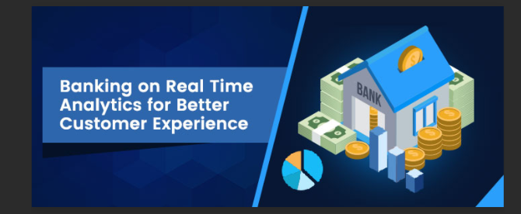

**Increase in profit:**

* Advanced analytics can help banks wring small improvements out of almost all their everyday activities, boosting the traditional P&L levers. Potential moves include the following:
* *Accelerating growth, even in an anemic environment.* Deeper and more detailed profiles of customers, together with transactional and trading analytics, can improve the acquisition and retention of clients, as well as cross- and upselling. For example, one bank used credit-card transactional data (from both its own terminals and those of other banks) to develop offers that gave customers incentives to make regular purchases from one of the bank’s merchants. This boosted the bank’s commissions, added revenue for its merchants, and provided more value to the customer.
* *Enhancing productivity.* Every banking process can become faster and more effective. Among other things, banks can use advanced analytics to provide faster and more accurate responses to regulatory requests and give teams analytics-enhanced decision support. One bank we know used machine learning to understand the way the characteristics of code affected a mainframe’s running time and the resulting costs; by optimizing the code, it cut them by 15 percent. Another bank used new algorithms to predict the cash required at each of its ATMs across the country, combining this with route-optimization techniques to save money.
* *Improving risk control.* Banks can lower their risk costs through analytics-aided techniques, such as digital credit assessment, advanced early-warning systems, next-generation stress testing, and credit-collection analytics. The expense of compliance and control has soared in recent years, and banks can use analytics to get economic returns from their considerable investments. We estimate that G-SIBs can take out up to $1 billion a year in costs through a simplified portfolio of data repositories—building on work that most banks have already done—and through new analytics that produce more accurate regulatory reports and deliver them more quickly. D-SIBs can save up to $400 million annually. Further out, banks will be able to use analytics to reduce fraud losses.
* A second vector of impact is the way that analytics can help *deliver the promise of digital banks* and offer a much better customer experience at a fraction of the current cost. In some regions up to 65 percent of customers now interact with their banks via multiple channels. Their paths through them are extraordinarily complex: they often start in one channel, perform intermediate steps in others, and finish in yet another—with plenty of pauses and information-gathering loops along the way. [Successful digital banks](https://www.mckinsey.com/industries/financial-services/our-insights/building-a-digital-banking-business) deliver a truly seamless multichannel experience by gathering real-time data and using analytics to understand the customer and build the proper (and always consistent) journey view.
* Finally, analytics can help banks *find new sources of growth*, and even new business models. Banks may be able to reap income from their data—for example, by sharing customer-analytics capabilities with new ecosystem partners, such as telecom companies or retailers. Taken to a logical but not implausible extreme, banks can use data and analytics to shape a new business model and out-fintech the fintechs. The bank as data company can sit at the center of a consumer ecosystem where the revenue pools include not just banking but also many other B2C and B2B businesses. Great analytics isn’t the only requirement here: banks must get many other things right to be relevant to and trusted by customers. But that can be done, and already more than a dozen leading banks are taking positive steps in this direction.

**Dashboard: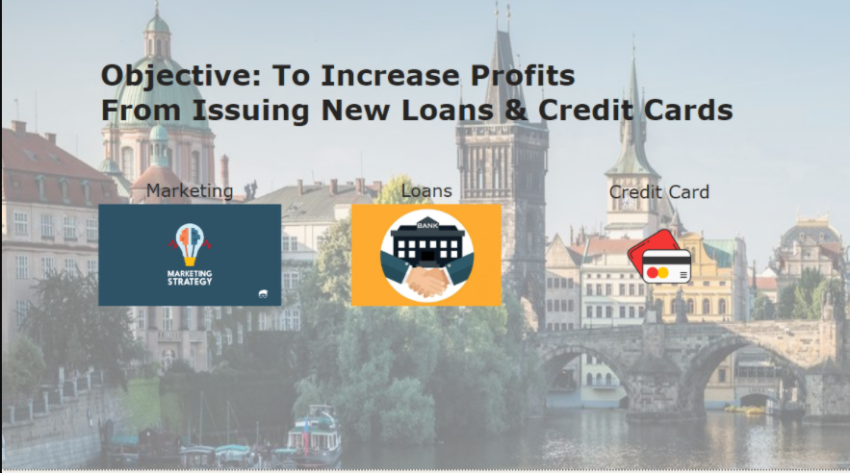**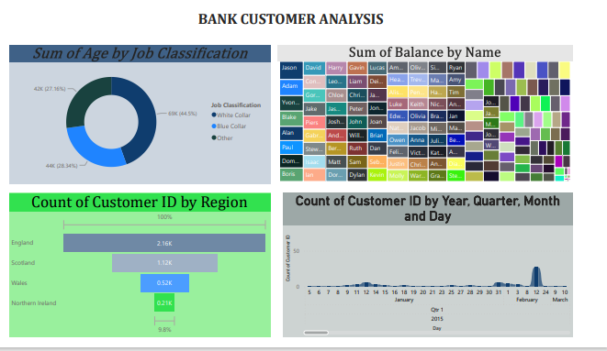

**3. Conclusion:**

Analytics used to be a term reserved for data scientists - a word heard by many, but understood by a few. This is no longer the case. Enterprises that do not reap the benefits of analytics will soon be edged out by their competitors. With data being a key component in any business today, enterprises are forced to look for new ways to analyze this data and gain insights into their business. Thus, in today’s business world, analytics has become vital to improve customer experience, increase market reach, optimize budget spend, enhance business processes, and find and eliminate anomalies. All of these eventually translate to improved revenue for any business.

It’s clear that streaming analytics is widely applicable within the banking & finance industry, helping organizations to get a better grasp of current trends, secure portfolios from adverse market effects, and safeguard investors from unscrupulous behaviour of fraudsters.

**Link:**Top of Form

**https://github.com/Paripurani/Real-time-analysis-Bank-Customers**